**CREATE THE FLASK APPLICATION**

Flask code and running:

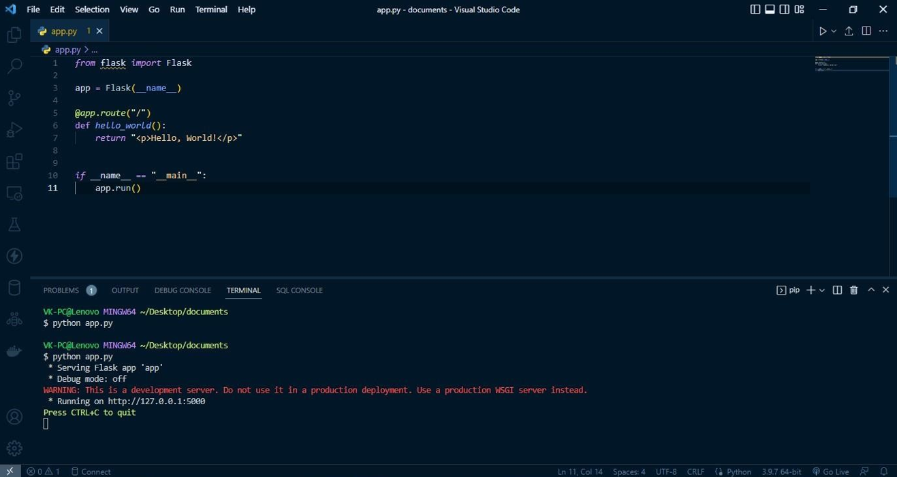

Output:

